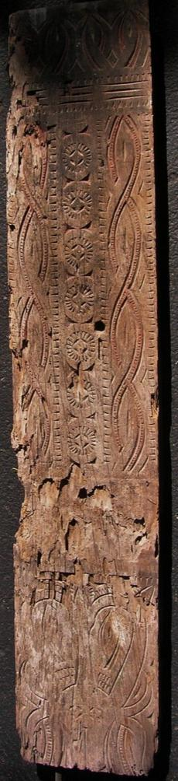DIS-Indo-Celebes-Sulawesi House Panel, Final

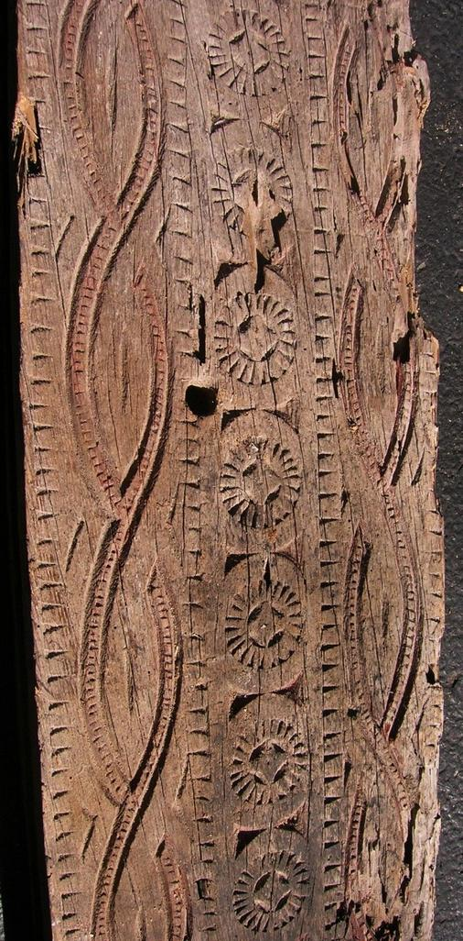native wood, 60 in. high, Ex Bouck Estate, New York City, 2014.

This house panel reflects the maritime existence of the Macassar

Sulawesi (formerly known as Celebes) in Indonesia, is reckoned by some as one of the four Greater Sunda Islands, including Java, Sumatra and Borneo and is considered within the Malay Archipelago. Sulawesi comprises four peninsulas: the northern Minahasa Peninsula; the East Peninsula; the South Peninsula; and the South-east Peninsula. The Strait of Makassar on the western shore separates it from Borneo.

Motifs on this hous panel echo the motifs found on Pre-historic to Proto-historic ceramics:

SHAPE \* MERGEFORMAT 

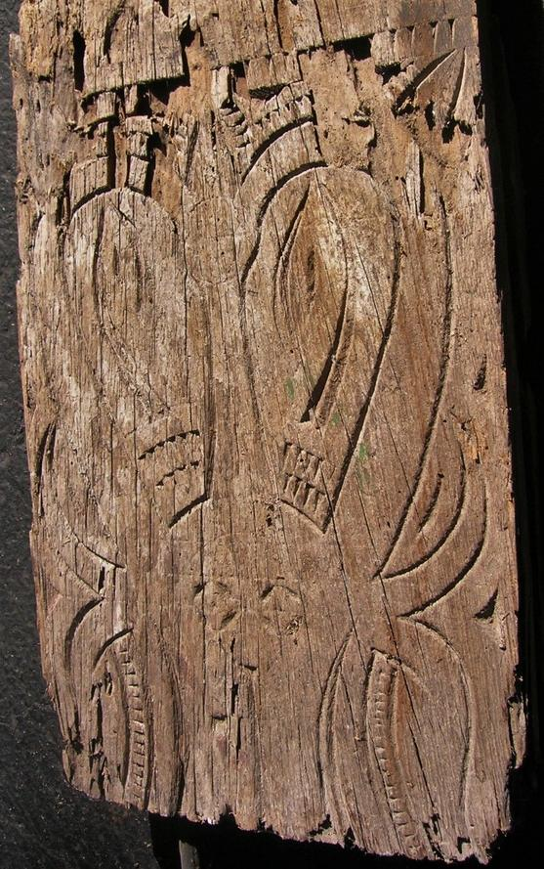

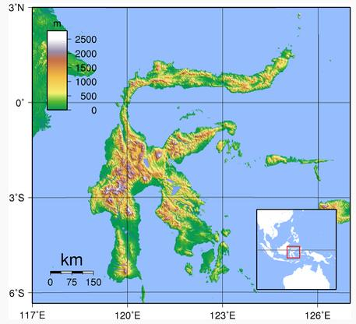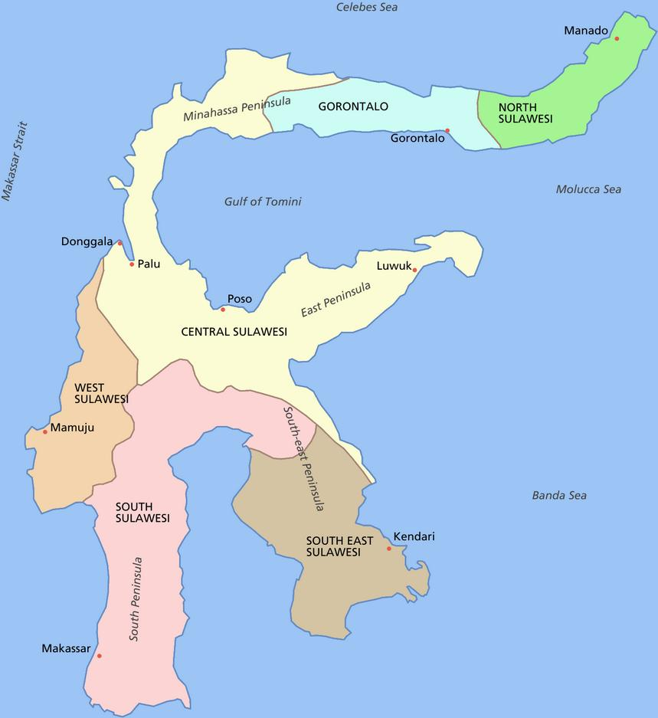

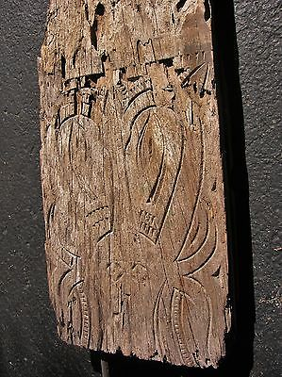

#### [SULAWESI HOUSE PANEL, WATER BUFFALO 60"](http://www.ebay.com/itm/321877601386)

|  |  |
| --- | --- |
| Item price | $89.99 |
| Quantity | 1 |
| Item number | 321877601386 |
| Shipping service | USPS Priority Mail |

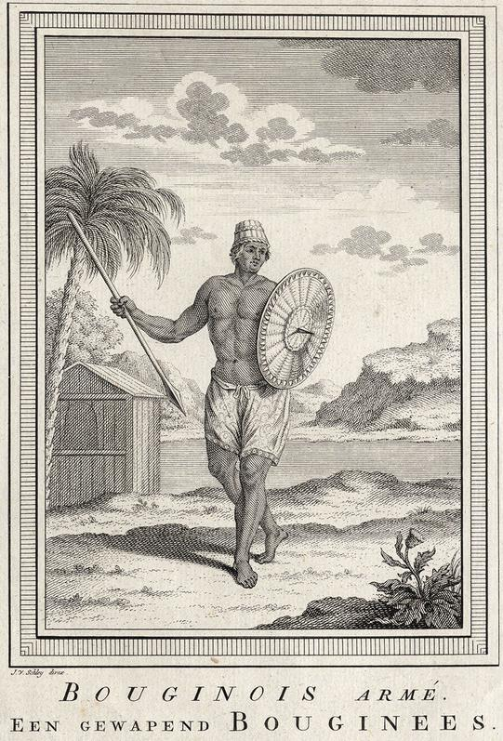

This engraving, (ca. 1600-1609) when the account was originally written, shows man armed man with a bronze spear and bronze shield from Sulawesi, Indonesia, [now the Celebes]. From Antoine François Prévost D'Exiles, *Histoire des Voyages, vol. 10, Voyage aux Indes Orientales 1600 et 1601 (premiàre Entreprise de la Compagnie des Brabancons) Second Voyage aux Indes Orientales 1606-9****,*** [S.L., *ca*. 1750] engraving by Jan van Schley (1715 **-** 1779), published ca. 1750. 'Bouginois Arme - een gewapend Bouginees.'. According to Charles Hamilton Smith, *The natural history of the human species: its typical forms, primeval distribution, filiations, and migrations* (London, Gould and Lincoln, 1859), p. 251 " Celebes is principally inhabited by the Boun, Bouginee, Bilges, or Bugesses, of which one nation is called the Macassar, and the whole appear to be of the same stem as the Horafouras. Here they are again fairer than the Malays, with very long black hair, and soft silky beards and whiskers. Their original language, more allied to southern dialects of India, with the admixture of Sanscrit, is now much corrupted by the Malayan."